Weebly is one possible option for you to use to create a teacher webpage. You will need to go to www.weebly.com and create a free account.

Using Weebly to Create a Teacher Webpage

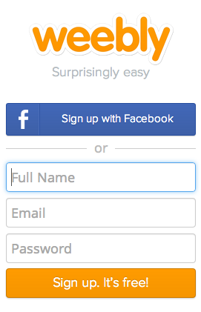

The first page will ask you to select a theme. You can choose one now, but this can always be changed later should you change your mind. You can scroll through all of the themes, or you may focus on one particular style using the drop down menu in the top right hand corner of this page.
You can also customize your search based on color as well if you so choose.

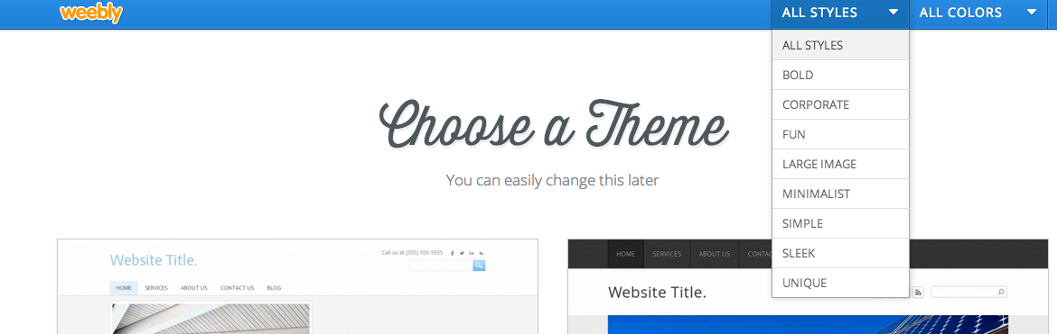

Once you find a theme you want to start with, move the cursor over the theme, and a “Choose” box will appear in the lower right corner of the theme page. Click “Choose.”

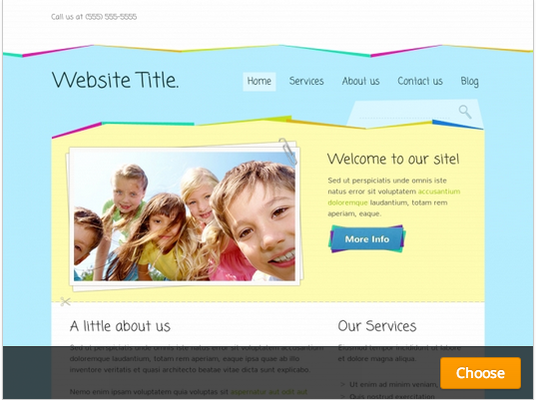

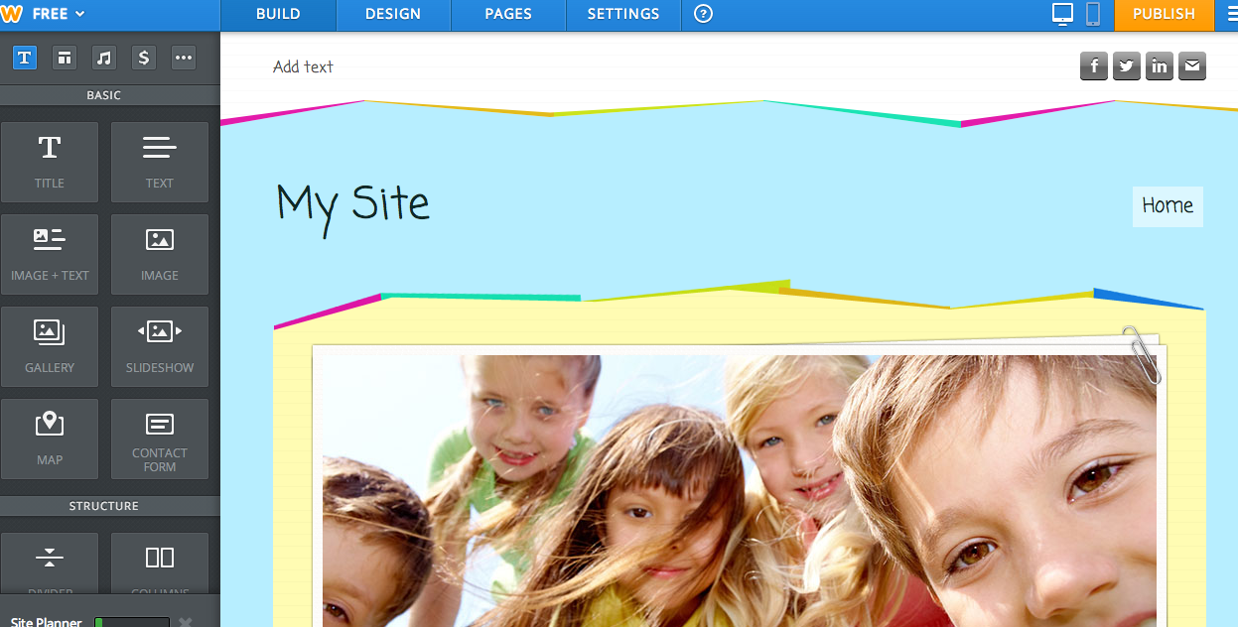

Once you’ve selected the theme, a page will pop up asking you to choose your website domain. You will be able to do this later so click on the X to leave this page.

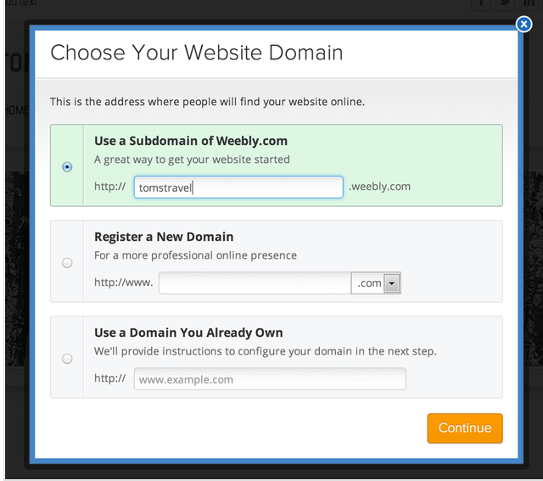

You will now see the template you chose as your page, and you are ready to get to work building the website.

You can change the name of your site by clicking on the words “My Site” and typing what you’d prefer to name the site.

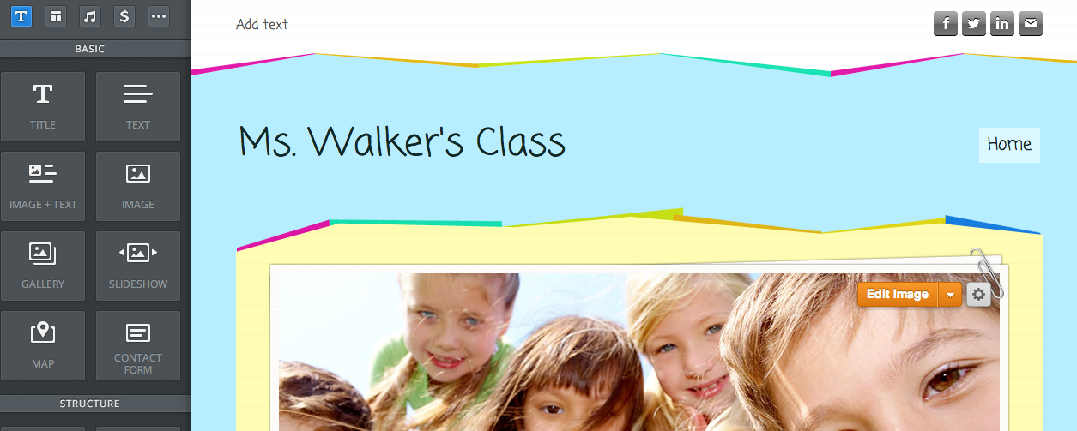
By moving your cursor over the image, you will get an option to “Edit Image.” Click this in order to change the picture if you choose to do so.

When you click “Edit Image,” you will get a new screen that will allow you to either click “Add Image” or “Use the original image.” If you wish to use the original image, you click that and will be led to a page that will allow you to add the original image. If you choose to add a different picture, click “Add Image,” and you will be given options for adding a different image. You will be able to add an image from your computer or search images.
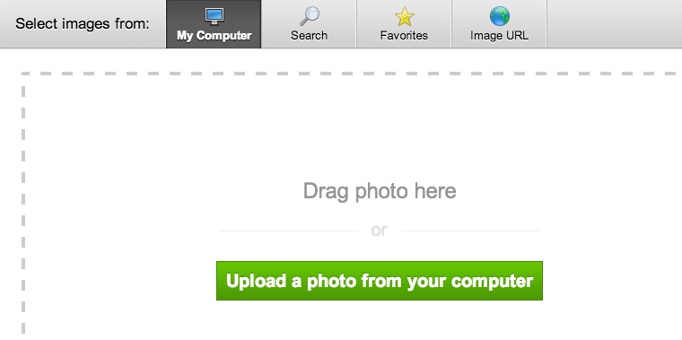
Click here to search for photos. You will be led to a page that will allow you to enter key words. Your search will yield both professional photos that you must purchase or free photos. Use the tabs to move between the two types of photos.

Click here to choose photos you have on your computer. You will then search for the photo you wish you use and click “Open.” The image will drop into the photo box and automatically be cropped to fit.

You may click and drag the picture to move to whichever portion of the image you wish to have shown. You may also wish to use the tools across the top to make additional changes to your image.
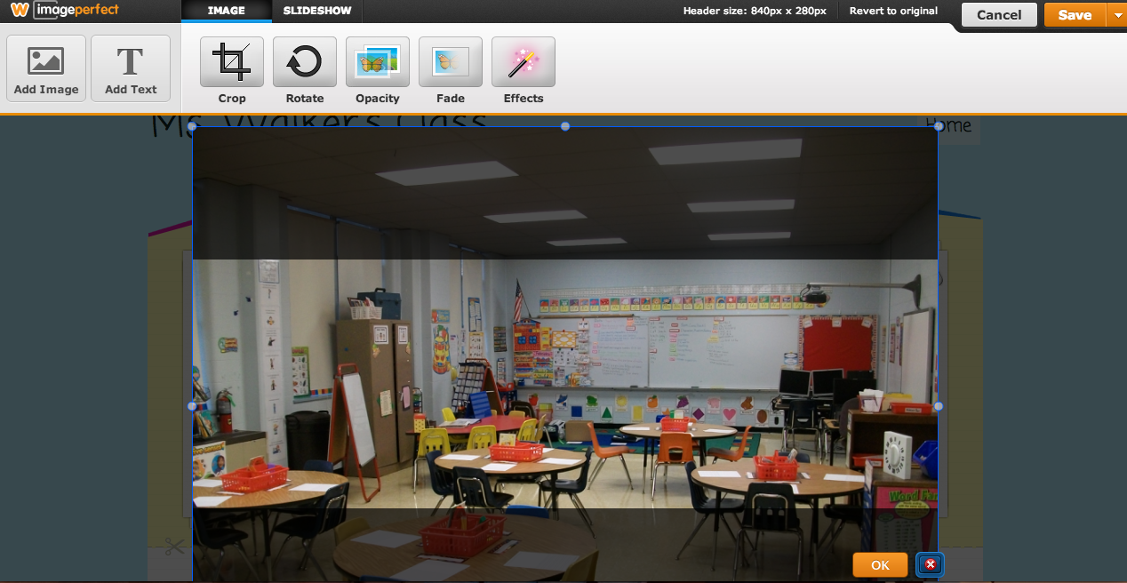

Once you have your image as you wish it to appear, click “OK.”
Then click “Save” in the upper right corner. If you click on the arrow to the immediate right of the “Save” button, you will be given additional saving options.

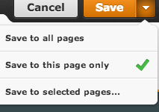
You may save the image to all your pages, to only the current page, or to selected pages.

You may now wish to add information down below the title and the image of your site. You may choose the organization of this information by clicking and dragging the style you wish to use from the choices on the left down to the area under your image.
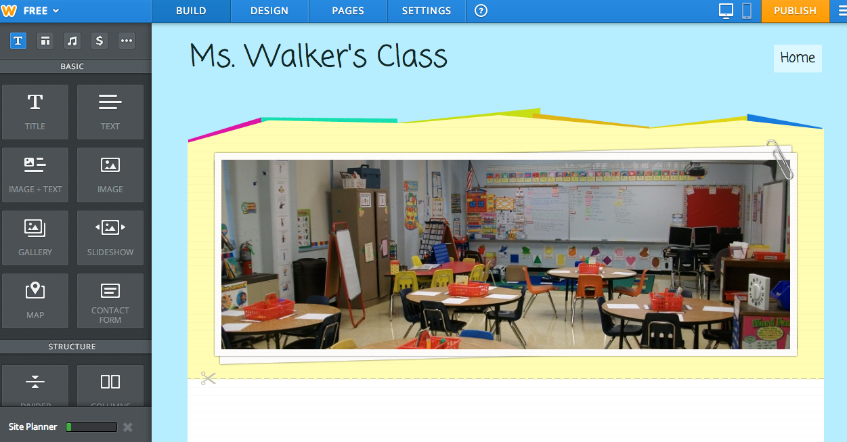
Click and drag here.

In the screen shot below, the owner clicked on “Image + Text” and drug it down to the area below the image. The message was then typed in the text area. A tool bar appears in order to allow you to format the text.
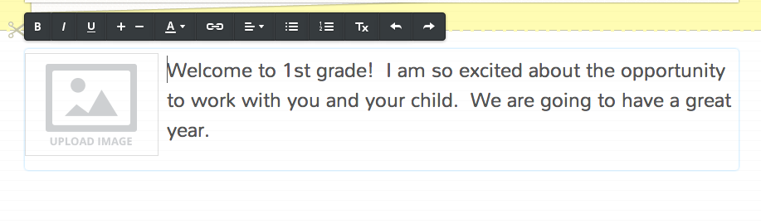
An image can be added in the same manner as explained above if you have chosen an option that includes an image. Simply click on “Upload Image, “ and you may choose from your own photos or search for professional or free photos.

Back at the top of the page on the right, there are icons for Facebook, Twitter, LinkedIn, and email. You control which of these icons appear on your page and to what content they are linked.
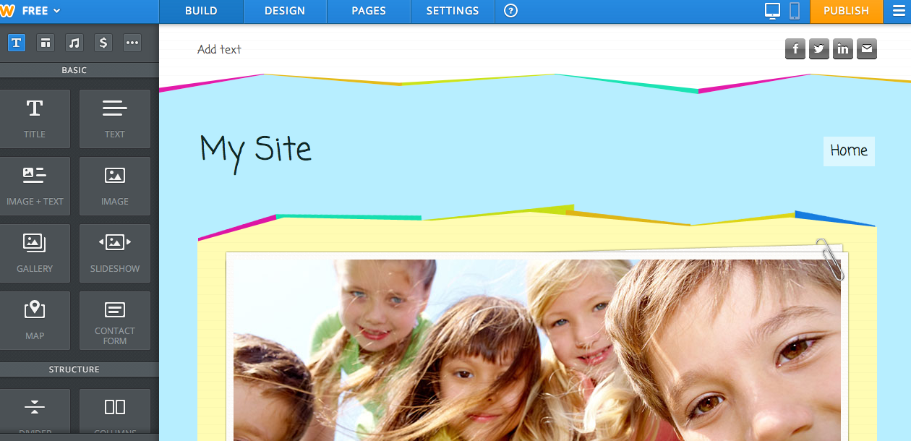

By moving the cursor over the icons, a box appears that allows you to input the link information.
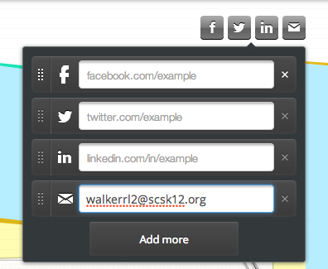
If you do not wish to have a link to your Facebook account, you may click the X to the right of the Facebook icon.

The other icons can be removed in the same way.

Notice here that an email address has been entered. This will keep the email icon active and allow those viewing the site to click on it to send an email.

If you wish to add more icons, you may click the “Add more” option. A menu will appear with additional choices.

Once you have finished making selections and entering link information, click back out on the page, and you will see the icons you activated shown on the page.

Now that you have your welcome screen ready, you will need to add the other pages you wish to have on your site. Click on “Pages” at the top.

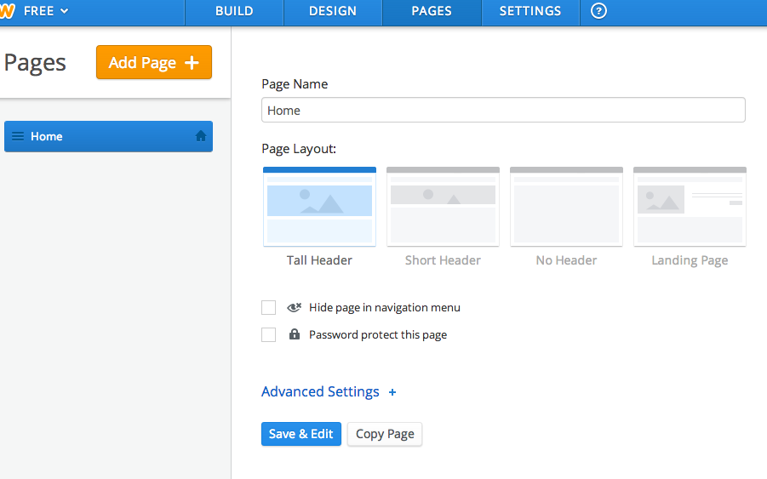
You will be able to click “Add Page +” to add as many pages as you like. You may name each page and also select the layout you wish to use for the page. Below is an example of the types of pages that you might wish to create.

Please note that the Class Information Page has a sub-page underneath it. Sub-pages should be created as pages first. In the example below to the left, “Calendar” was created as a page, just as “Schedule” and “Supply List.” “Calendar” was then clicked and drug to the right under “Class Information.”

Simply clicking and dragging up or down will only change the order of the pages. You must pull to the right while still clicking in order to create a sub-page. In the example below to the right, you see that “Schedule” and “Supply List” have now both been pulled as sub-pages under “Class Information.”

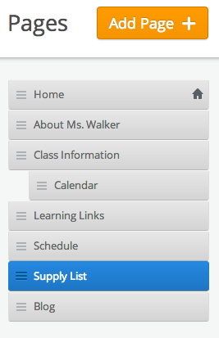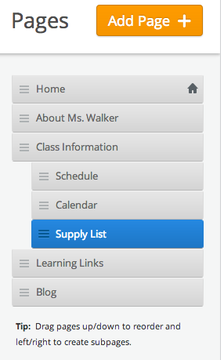

When you return to the Build area of the site, you now see the options that exist for users of the site to access your various pages.

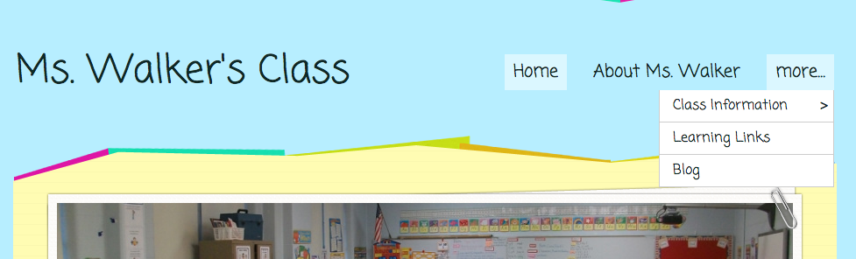
Notice the arrow next to “Class Information.” This will lead users to the sub-pages that were created under that page.

Each of your new pages will also need to be set up. You may click on the links to go to each of your pages. As with before, you may change the image if you wish. Then you may use the Build tools to the left to add the elements below the image that you wish to have on that page. Below is a sample of the About Me page.

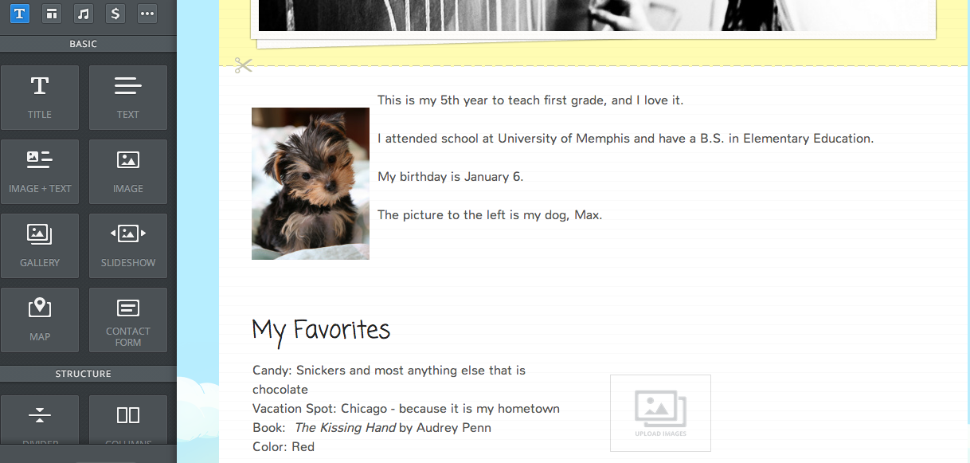

The first element used was “Image + Text.”

The “My Favorites” used the “Title” element.

At the bottom of the screen, there are two columns. This was done by dragging and dropping the “Column” option in to the area. Then the “Text” option was clicked and drug into the left column, allowing the owner to simply type. On the right, the “Gallery” option was drug and dropped. When the owner clicks on the icon in the gallery area, she will be able to upload photos.
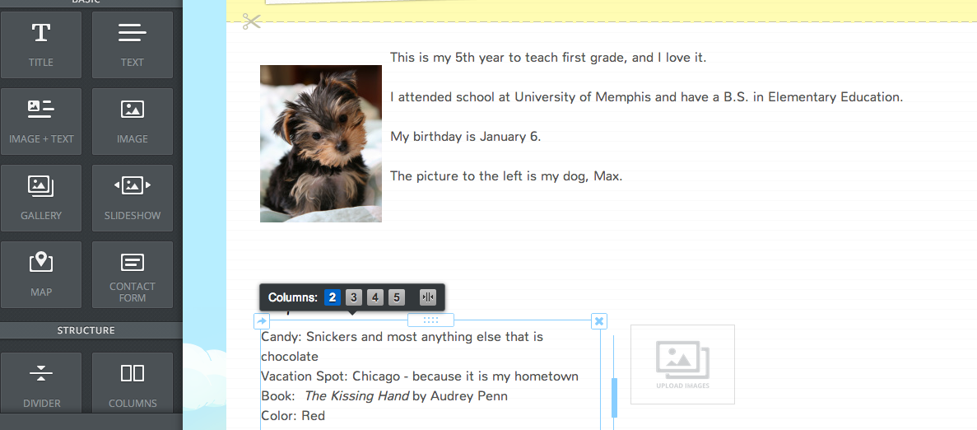
When the “Column” element is used, the owner may select the number of columns. In this example, only two have been used.

Below “Gallery” was selected, and the owner will be able to select multiple images to display. “Slideshow” might be another option to consider here.

All other pages can then be created following the same directions. Weebly offers various options in the Build toolbar for including information.

Newsletters, calendars, schedules, rubrics, etc. may be uploaded and displayed directly on the page by using the “Document” element.

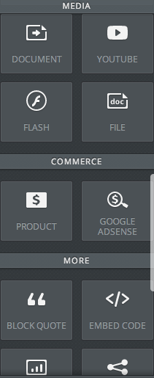
The “File” option will allow you to create a link to a document.

The possibilities are endless; so for more information about what else you can do with Weebly, please visit http://www.weebly.com/weebly/main.php.

Once you have finalized your site, you will need to publish it in order that others may view it.

Click “Publish” in the upper right hand corner. You will see the screen that you saw earlier.

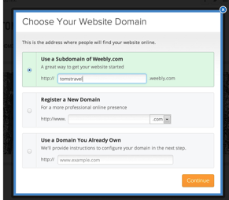
You will be able to choose your site name here. You may wish to use your school name and your last name or any combination that is not already taken. As you type your desired site name, you will see a message that indicates whether the name is taken or is still available.

Once you have a name, you will click “Continue.”

The next screen should indicate that your site has been published! If you click “Continue,” you will be taken to a screen that offers options for purchasing upgrades. This is NOT necessary for having your site published. Simply close out of that screen.
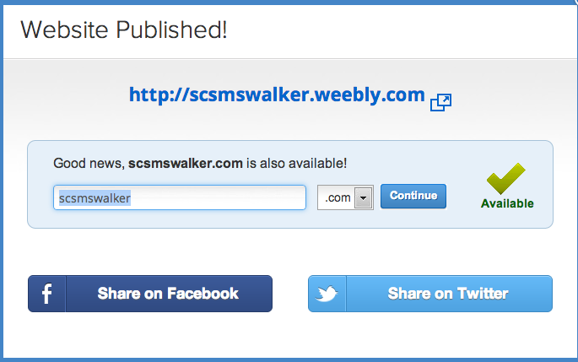

Now go view your new website and begin sharing it with your students and parents!

